**Instructions for using “The Incredible Focus Finder”**

1. Convert Volocity images to TIFFs
   1. Select all files for analysis in Volocity, choose File, Export, and create a new folder for the images
   2. Export specifications: Format = TIFF; Naming- check “Append item name”; Options-choose one file with multiple images, channels separate, and planes merged

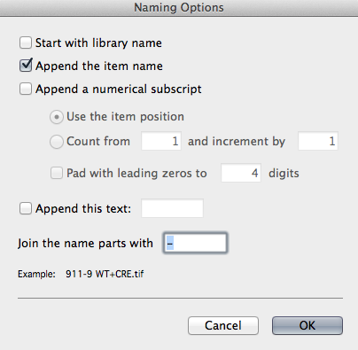 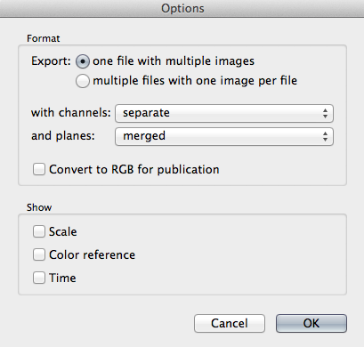

1. Re-number TIFFs
   1. Manually fix the first image captured with each label by adding the numeral “1” at the end of the name
   2. Select all TIFFs, hold control and click to open a menu box, select Services and then “add 4 digits start 301”
   3. Rename items by adding 4 numbers at the beginning of each name- set options as indicated below
   4. Make note of which numbers correspond to each sample

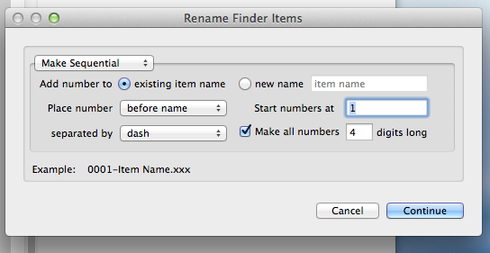

**Manual Version:**

1. Determine brightness/contrast and thresholding values for first channel (ex. Telomeres)
   1. Open one test image in Fiji
   2. Separate channels by selecting the Image menu, then Stacks, and Stack to Images

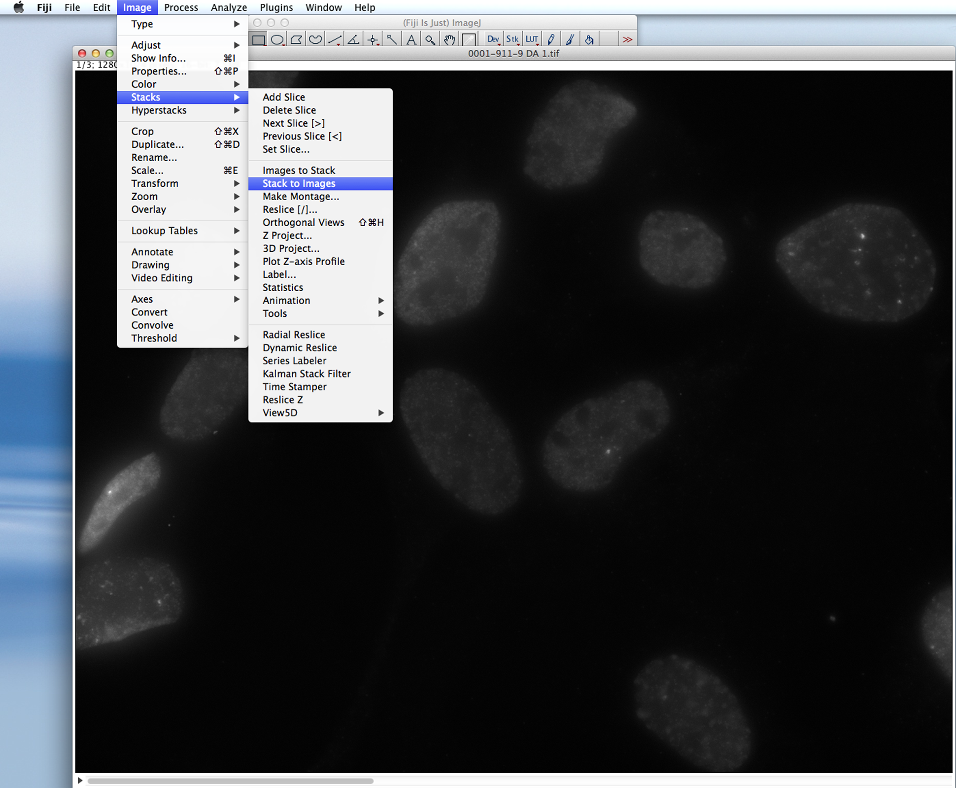

* 1. Close the DAPI channel
  2. Obtain a median filtered image of the first channel: duplicate the appropriate image and select Process, Filters, Median (radius = 10 pixels)

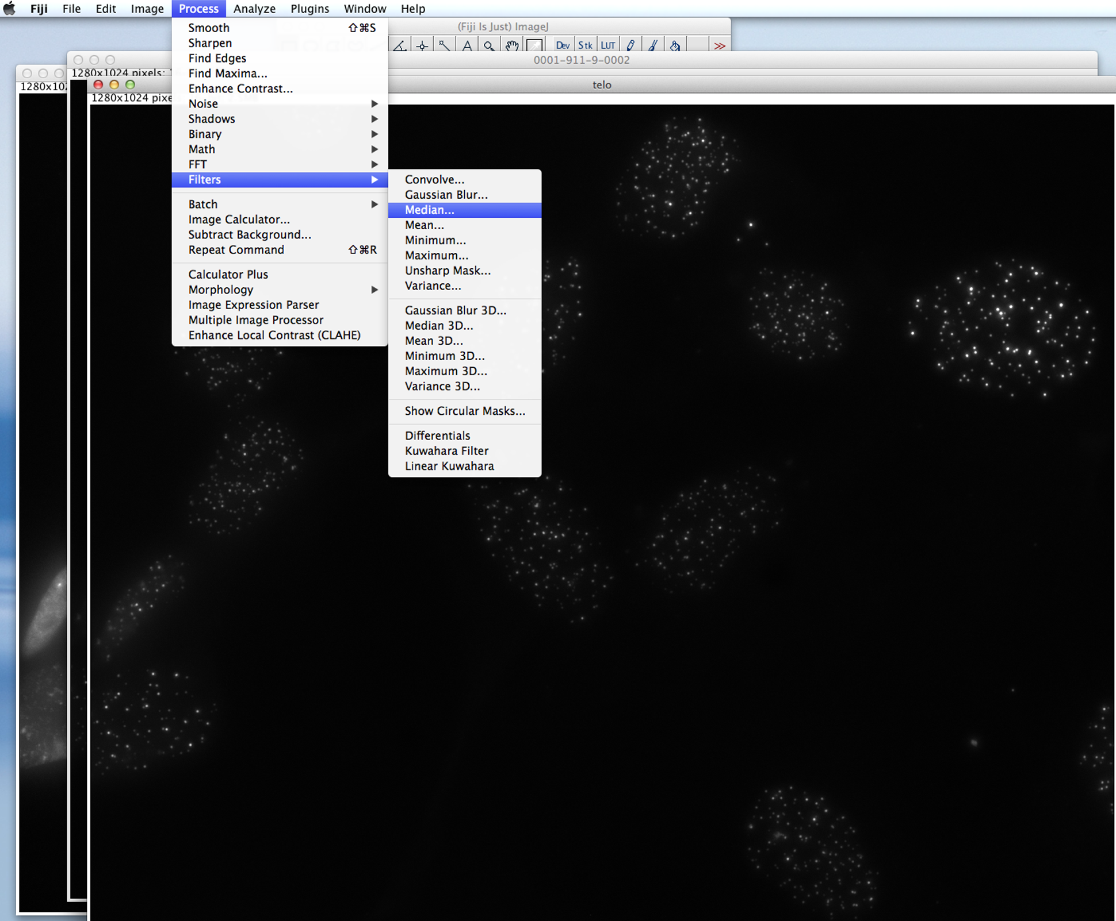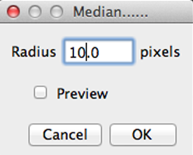

* 1. Subtract the median filtered image from the original: select Process, Image Calculator. Image 1 is the unaltered, original image. Choose Subtract for the operation. Image 2 is the median filtered image. Check the indicated box to create a new window with the median filtered image.

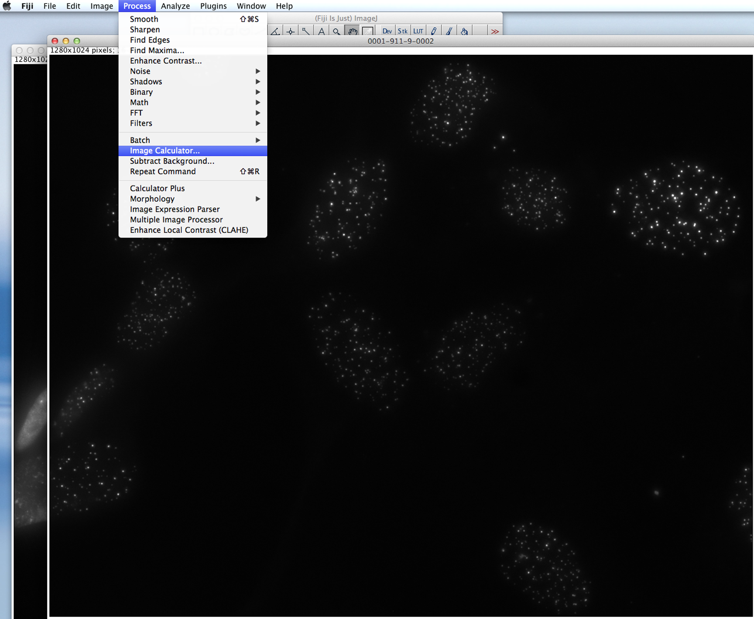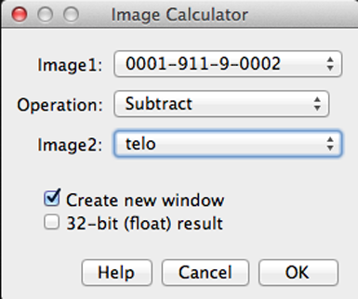

* 1. Using the median filtered image, change the image type to 32 bit and subtract the background: select Image, Type, and 32 bit. Then select Process, Subtract Background (rolling ball radius = 14 pixels).

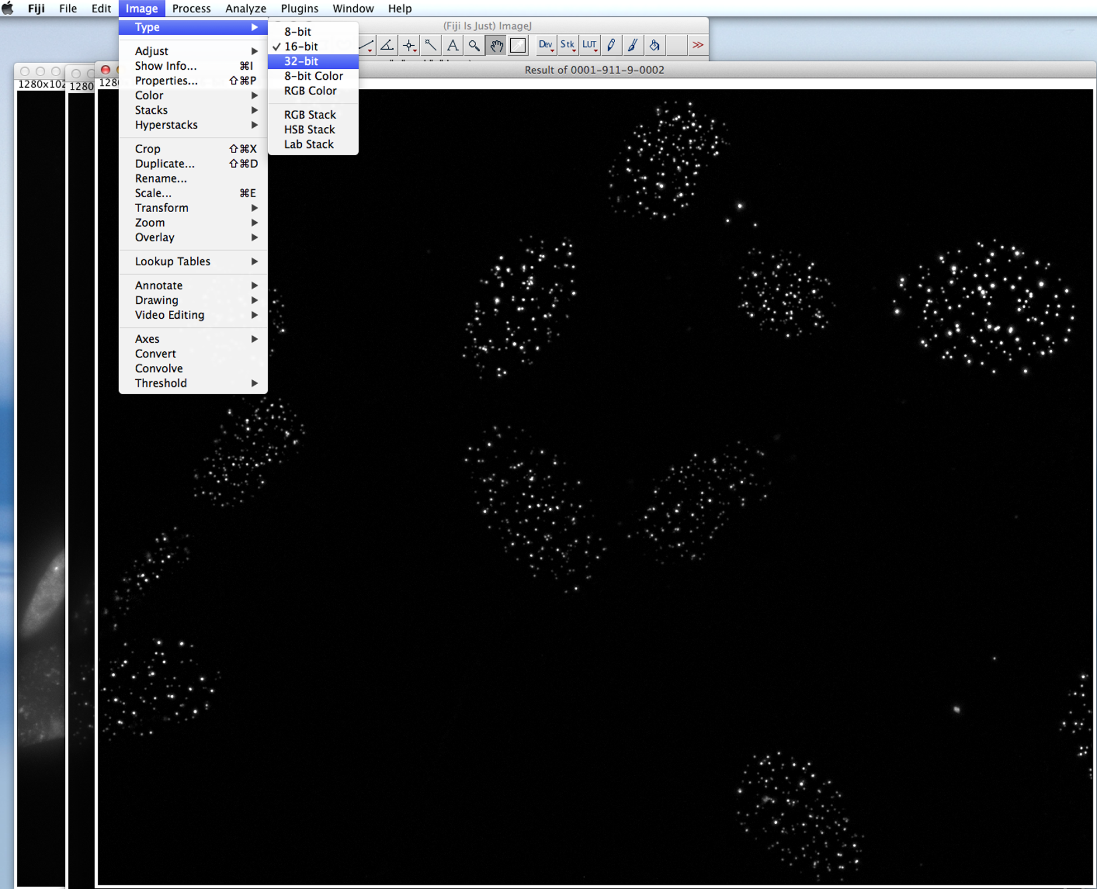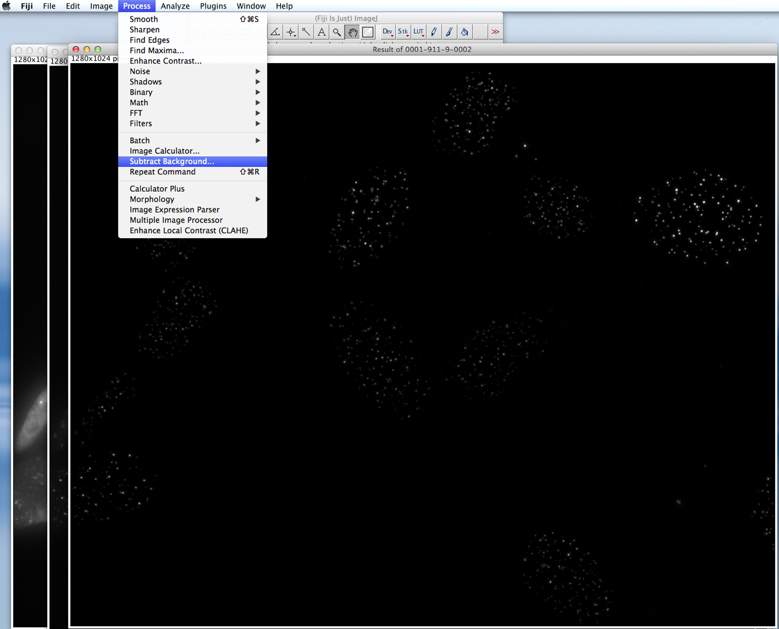

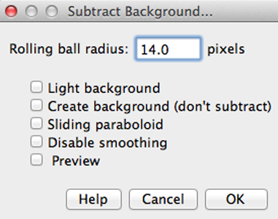

* 1. Adjust image type to 8 bit and despeckle to reduce noise: select Image, Type, and 8 bit. Then select Process, Noise, Despeckle.

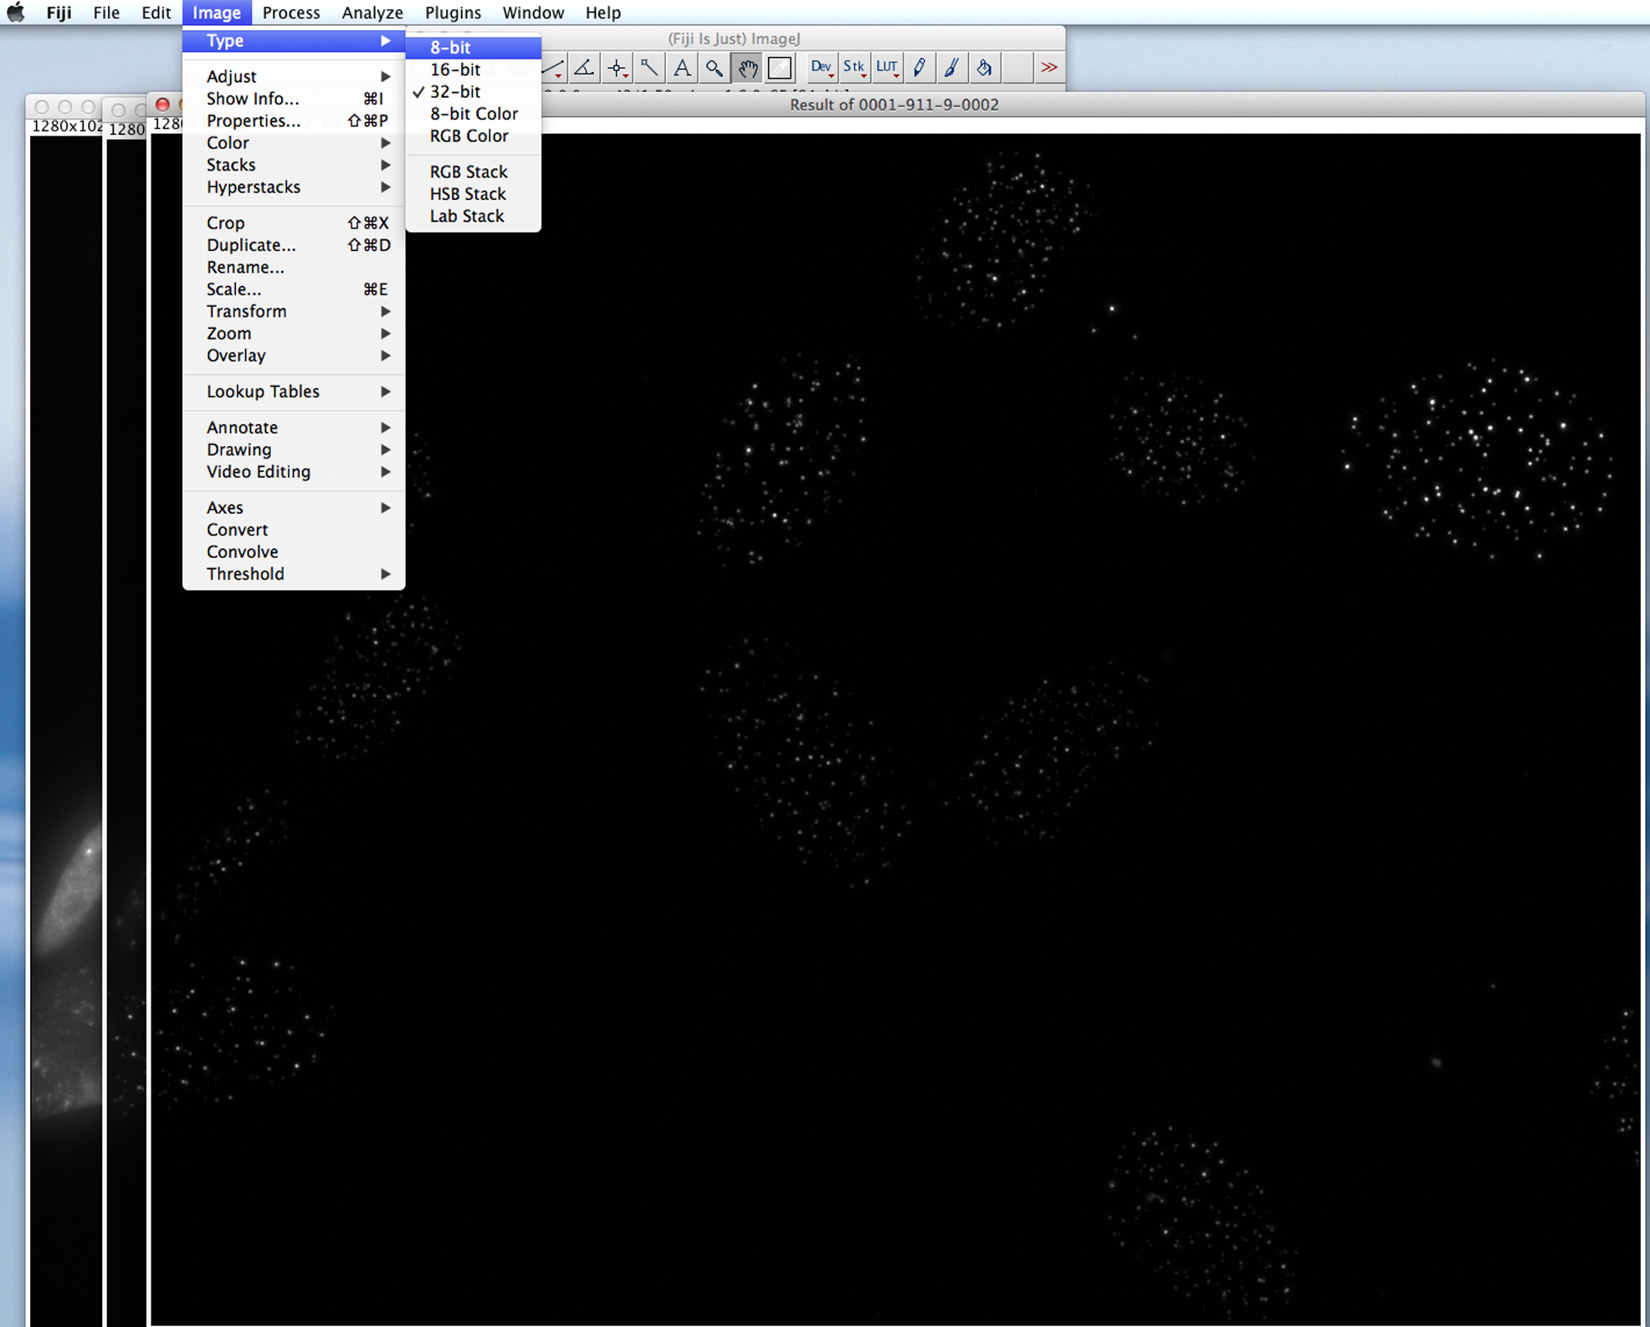

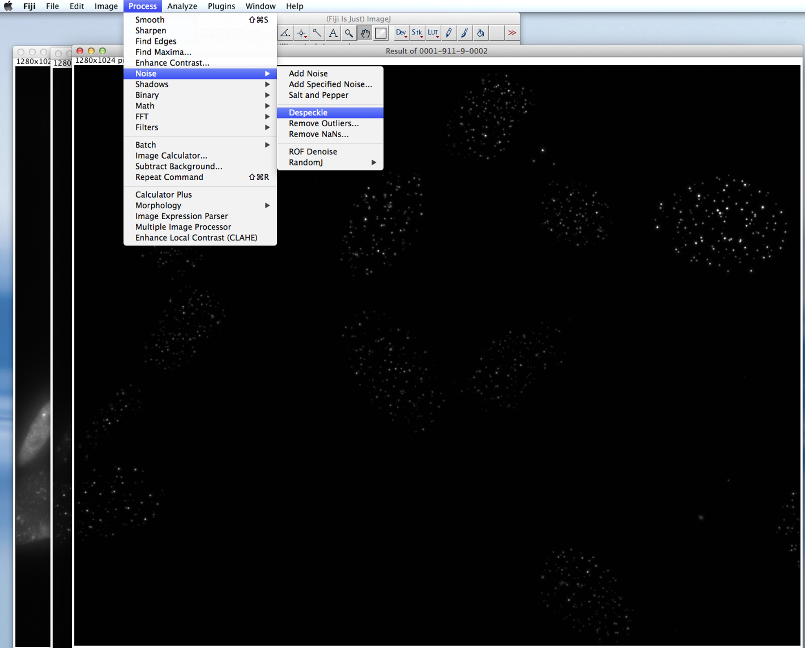

* 1. Duplicate the resulting image and use this as the working image (do not apply upcoming changes to the original image)
  2. Select Image, Adjust, Brightness/Contrast

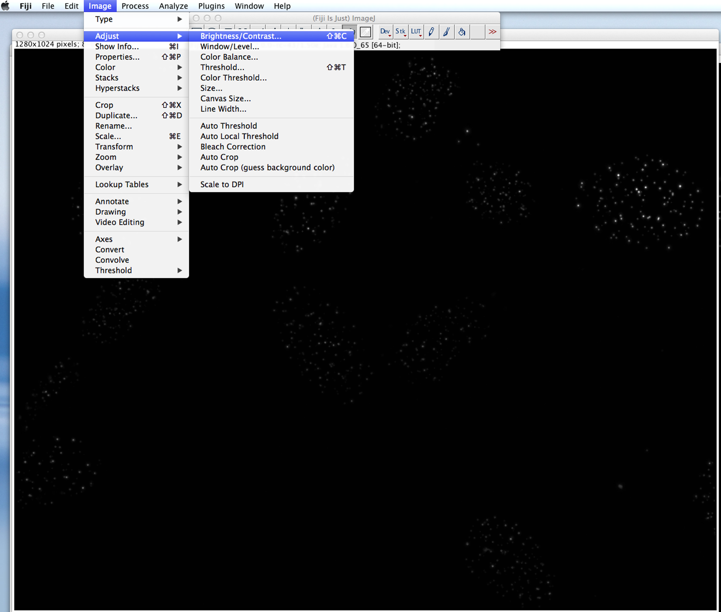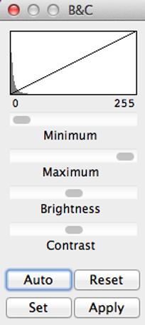

* 1. For the telomere channel click Auto and then Apply in the B&C window
  2. Zoom in and move the cursor over individual telomere signals to determine the range of signal values (signal value is shown at the bottom of the Fiji tool box; max = 255). The purpose is to identify a cutoff value for detecting a signal as a telomere. Generally, the telomere signals are above 50-60 and this range is appropriate for discriminating telomere signals from background noise.
  3. Once a cutoff value has been determined, select Image, Adjust, Auto Local Threshold. Change Method to Mean and Radius to 500. Parameter 1 is the cutoff value determined in the previous step, entered as -60. Select box for White objects on black background and hit OK.

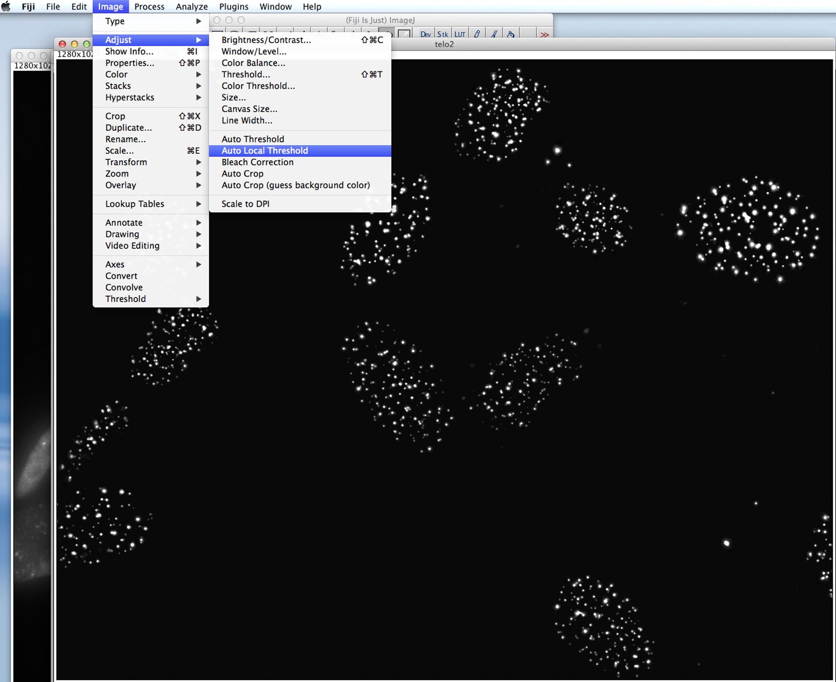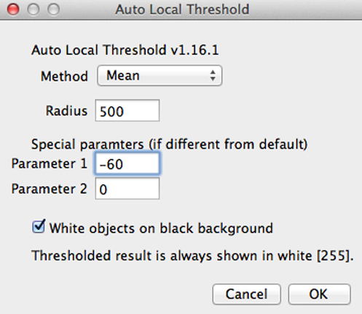

* 1. Confirm that the resulting image is reflective of the telomere signals in the original. Make adjustments in the cutoff value if necessary.

1. Determine brightness/contrast and thresholding values for second channel (BP1, etc)
   1. Duplicate the image and obtain a median filtered image
   2. Select Process, Image Calculator, and subtract the median filtered image from the original, creating a new window
   3. Using the median filtered image, change the image type to 32 bit, subtract the background, change the image type to 8 bit, and despeckle
   4. Duplicate the resulting image to use as the working image
   5. Select Image, Adjust, Brightness/Contrast
   6. Try Auto contrasting, but it will likely compress the image too much and make some background staining look like actual foci. Instead select Set and identify the display range (start with 0-60, will need to determine the range that looks appropriate). Click Apply.
   7. Zoom in and move cursor over individual foci to determine the range of signal values. Identify a threshold value that will remove background and still detect all foci.
   8. Select Image, Adjust, Auto Local Threshold. Change Method to Mean and Radius to 500. Parameter 1 is the threshold value determined in the previous step, for example -80. Select box for White objects on black background and hit OK.
   9. Confirm that resulting image is reflective of the foci apparent in the original. If necessary, go back and adjust the display range and threshold value.

**Automatic Version:**

1. Select Plugins, Macros, Value Tester
   1. Open an image you would like to test
   2. Enter the number of channels
   3. Enter which channel is DAPI
   4. Decide whether you would like to test auto-contrasting on the second foci or not?
      1. If not, determine which values you would like using the slider. Press OK, **NOT APPLY**
         1. You can “preview” what auto-contrast would look like by hitting auto. If you don’t like it, hit reset.
   5. Zoom in to identify the cutoff values for the foci. When you are done, press OK.
   6. Enter the value you determined in step e.
   7. Repeat steps d-f for the other foci.
   8. Review your results, then press OK. A log window will be printed with the relevant information.
   9. If you would like to try again, either with the same image or a different image, enter Y. Otherwise, enter N.
   10. If you entered Y, go repeat from step A. The log window will add information as you run.
2. Write down the values from the log window for your own record or save them on your computer.

1. Open a different image in Fiji and repeat adjustments as outlined for both the telomeres and BP1 foci. Confirm that the parameters work on multiple images before running macro. (You may also use the Value Tester for this).
2. Run macro in Fiji
   1. Install macro: select Plugins, Macros, Install and choose “The Incredible Focus Finder.txt”
   2. Then select Plugins, Macros, The Incredible Focus Finder

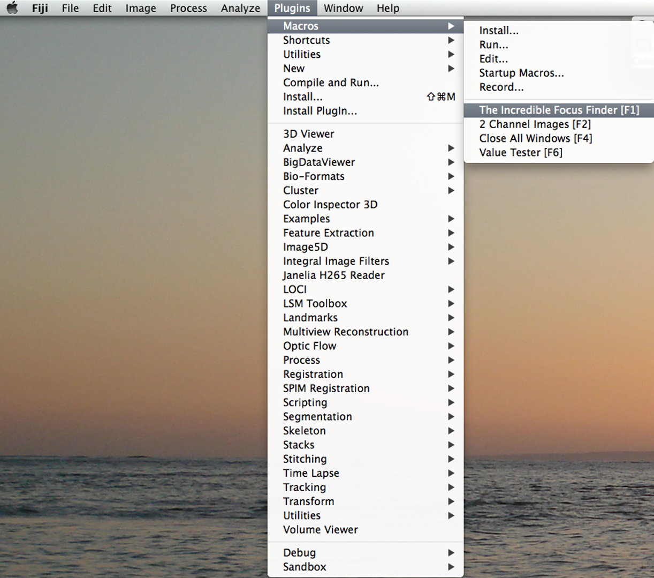

* 1. Choose Source Directory (folder containing re-numbered TIFFs, must only contain images)
  2. Choose Destination Directory- create new folder for analysis (must be empty)
  3. Enter number of channels when prompted
     1. If you selected 4 channels, select which of the channels need to be colocalized. This should be 2 of 4 possible channels.
  4. Enter yes or no to use auto-contrasting on the first foci
  5. Enter yes or no to use auto-contrasting on the second foci
     1. If chose not to auto-contrast, enter minimum value and maximum value for display range (previously determined)
  6. Enter threshold value for first foci (always a negative number)
  7. Enter threshold value for second foci (always a negative number)
  8. Enter the channel number containing DAPI staining
  9. Let the macro run. Five new folders will be created in the selected destination folder: BP1, Coloc, Image, Nuclei, and Telo. The Image folder contains TIFFs of each image adjusted according to the set parameters. Open all in Fiji and quickly browse images to confirm they were processed correctly. Nuclei contains the nuclei outlines. The other three folders contain a csv file for each image indicating the area of each nucleus and the number of foci identified (RawIntDen values that must be divided by 255). A text file is also saved containing the values you used.

**Manual Version:**

1. Analysis
   1. Use Terminal to combine the files for each image into one file: open Terminal, type “cd “ (space after the d) and then drag the BP1 folder in. Hit Enter. Type “cat *.csv >mergedBP1.csv” and hit Enter. This tells Terminal to combine every .csv file in the BP1 folder into a new file named mergedBP1.csv. The new file will appear in the BP1 folder. Repeat for the Coloc and Telo files.
   2. Convert RawIntDen values into foci counts: Open the excel file named “template formulas” and the merged BP1 file. Copy columns E through G from template formulas into the BP1 spreadsheet in the first open column. The middle column pasted indicates the image number and the last column contains foci counts, as formulas. Copy and paste the foci column back in place as values only. Highlight the foci column again and select Edit, Find. Type “#VALUE!” into the fist box, hit replace, and leave the second box blank. Select Replace All to remove this text from the foci counts column. Repeat for merged Telo and Coloc files.
   3. Copy foci counts into the excel file named “COUNTS TEMPLATE GOOD”. Be sure to copy images into the appropriate columns (for example, images 1-15 were –CRE, 15-20 were +CRE, etc. in each spreadsheet) Scroll down to see calculations for number of cells and % cells with >5/10/15/20 foci.
      1. Should remove any cells containing fewer than 20 telomeres: select all data columns, copy, and paste adjacent. Select the first telo column and sort in decending order (expand selection). Delete contents from the table if cells had fewer than 20 telomeres. Repeat for remaining data sets.

**Automatic Version:**

1. Analysis
   1. Drag TIFF Excel Merger.py and easygui into your output folder
   2. Double click TIFF Excel Merger.py to start the program
   3. Follow the prompts
      1. Select whether to exclude below 20 telomeres
      2. Select number of conditions, and which image # they start on
      3. Select folders
   4. The program will create an excel sheet for each condition you specified, including some standard analysis of the data.

Notes:

1. Value tester is compatible with 2, 3, or 4 channel images.
2. The macro is compatible with DV files.